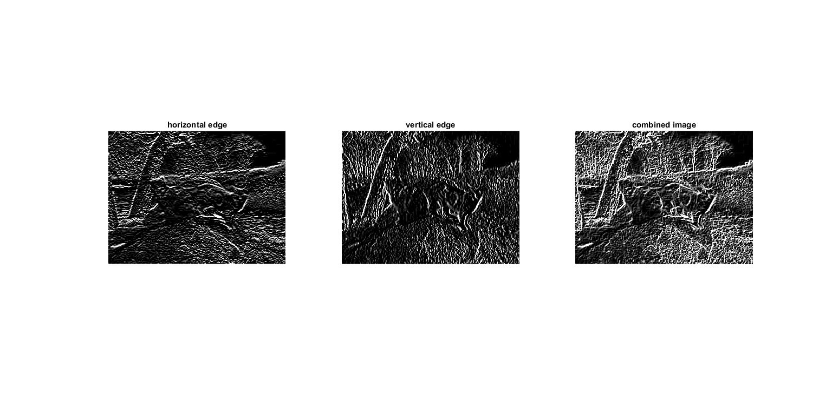

Code:

clc;clear all;close all;

i = imread('two_cats.jpg');

g = rgb2gray(i);

gx = edge(g,'sobel');

h = fspecial('sobel');

t = transpose(h);

horizon = imfilter(g,h,'replicate');

vertical = imfilter(g,t,'replicate');

comb = horizon+vertical;

subplot(131),imshow(horizon),title('horizontal edge');

subplot(132),imshow(vertical),title('vertical edge');

subplot(133),imshow(comb),title('combined image');